Table Name:Leasing

|  |  |
| --- | --- |
| Leasing1.JPG | Leasing2.JPG |

Table Name : LeasingDesciption

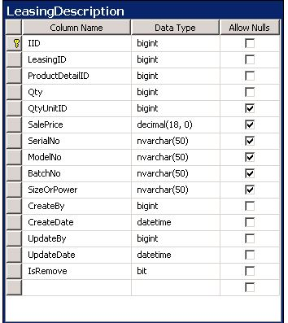

Table Name : LeasingDescriptionLog

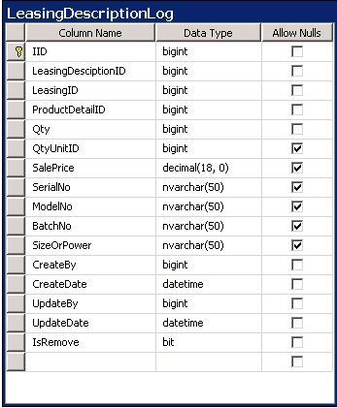

Tabel Name : LeasingInstallmentCollection

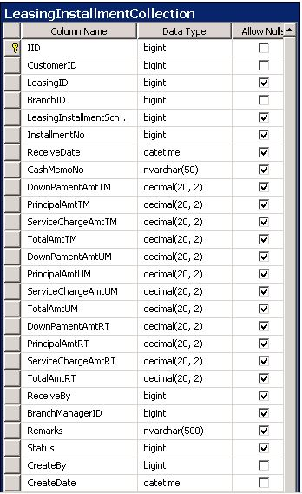

Table Name : LeasingInstallmentSchedule

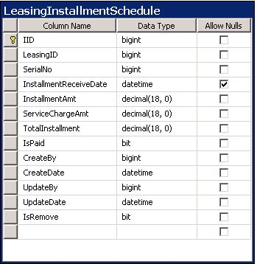

Table Name : LeasingInstallmentScheduleLog

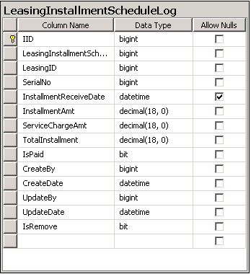

Table Name : LeasingLog

|  |  |
| --- | --- |
| LeasingLog.JPG | Leasinglog2.JPG |

Table Name : LeasingSalesReturn

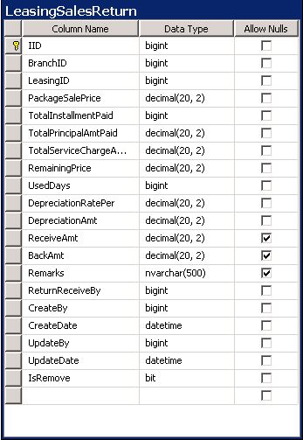

Table Name : PackageInfo

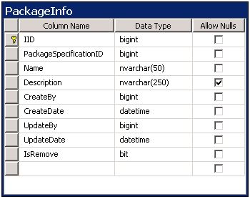

Table Name : SparePartSales

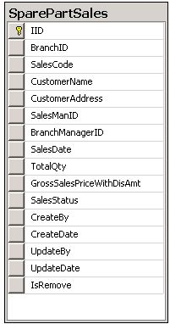

Table Name : SparePartSalesDetails

